Creating tables

Create a table by entering data in a datasheet
If you already have a database and wish to add data to an existing table, do the following:
1 In the Database window, click Tables under Objects.
2 Click the name of the table you want to open.
3 To open the table in Design view, click Design on the Database window toolbar.
4 To open the table in Datasheet view, click Open on the Database window toolbar.
The screen shot below shows what you should see if you opened an existing database and are about to select the Ingredients table.
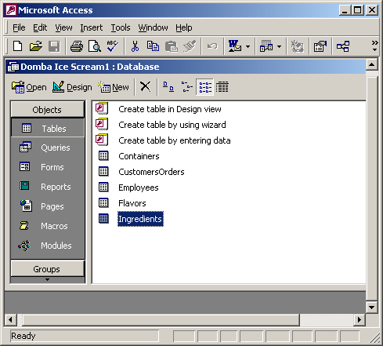
Double click your selection (in the example, the Ingredients table), and the table should open as a datasheet into which you can add data, as shown below:
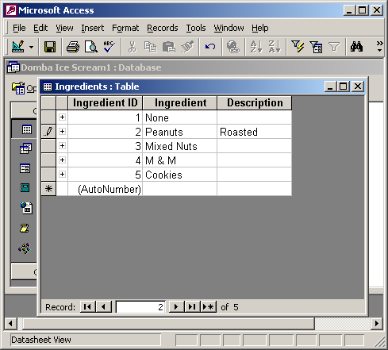

Create a table from scratch
In this example we have opened a blank database that, as yet, contains no database objects.
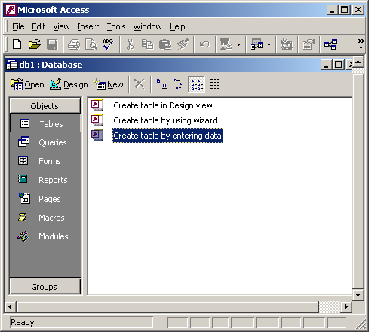
Selecting Create table by entering data opens a default datasheet with field names like Field1, etc, as shown below:
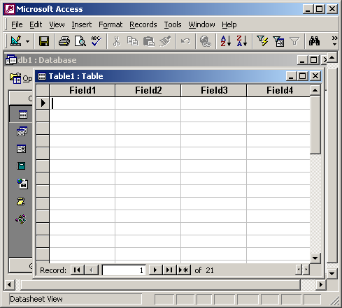
Enter data directly into a blank datasheet. Although this doesn’t look too helpful when you save the new datasheet, Microsoft Access will analyse your data and automatically assign the appropriate data type and format for each field.

Create a table from scratch in Design view
In the example below we have selected the option to Create table in Design View. This will enable us to create the field names and data type we need as well as setting features such as which field(s) are the primary key.
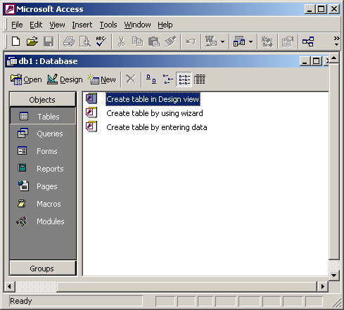
In the screen below we have labelled the first field First Name and selected Text as the Data Type.
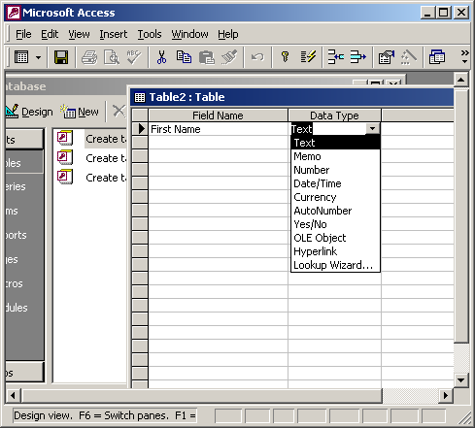

Create a table using a Wizard
Another option is to use a Wizard to build the table. This enables you to select from many sample tables, as shown below:
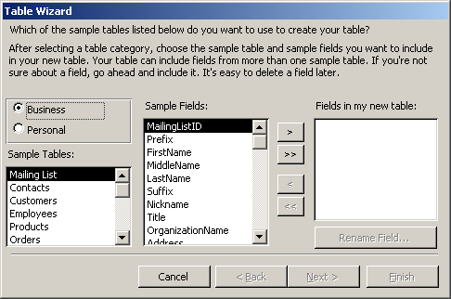

Create a new table from existing data
Access provides two ways to create a table from existing data:
1 You can import or link data from another Access database or data in a variety of file formats from other programs.
2 You can perform a ‘make-table’ query to create a table based on data in a current table.
These alternatives are not described here but you can readily use the Access built-in Help facility to find out more about them.

